

**Name: Muhammad Fahad**

**Sap ID: 37125**

**Section: BSCS-5A**

**Course: Computer Networking**

**Lab task#2**

**Task-1**

Drag & Drop All the END devices & Intermediary devices.

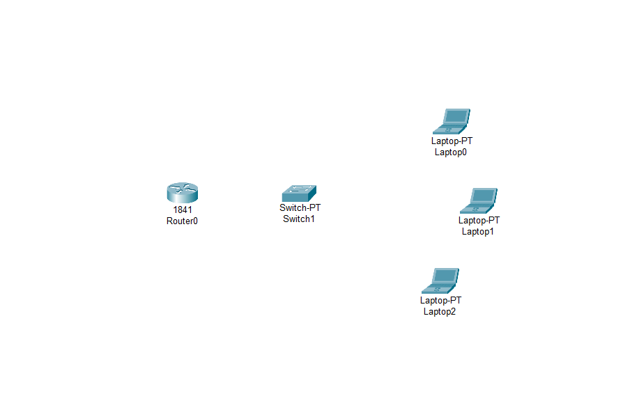

**Task-2**

Connect these Devices with Copper Cross over cable.

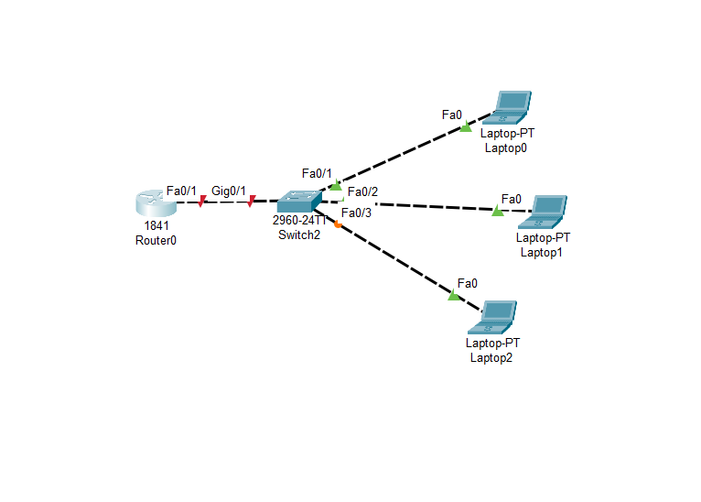

**Task-3**

Write down the cable name which is use to connect same devices and which port you use to connect devices.

**Cable Name for Connecting Similar Devices:** Straight-Through Ethernet Cable or Patch Cable.

**Port to Use for the Connection:** When connecting similar devices with a straight-through Ethernet cable, you should use the standard Ethernet (RJ-45) port on the devices. These ports are commonly located on the back or sides of the devices and have an RJ-45 connector interface. Plug one end of the cable into the Ethernet port of the first device and the other end into the Ethernet port of the second device.

**Task-4**

Suppose you have two devices and they are connected with each other. How do you check the connectivity between them. Explain with working.

Solution:

1**. Open a Command Prompt or Terminal:**

On one of the devices (let's call it Device A), open a command prompt (for Windows) or terminal (for Unix-like systems).

2**. Identify the Target Device:**

You need to know the IP address or hostname of the other device (Device B) to which you want to check connectivity. You can obtain this information from Device B or from your network configuration.

3. **Use the Ping Command:**

In the command prompt or terminal, type the following command and replace "target-IP" with the IP address or hostname of Device B:

```

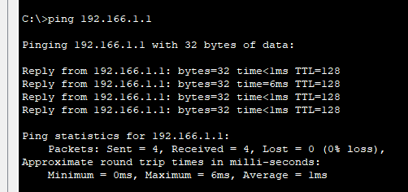 ```

**4. Press Enter:**

Press the Enter key. Device A will start sending ICMP echo requests to Device B.

**5. Observe the Results:**

If there is connectivity between Device A and Device B, you will receive responses. Each response will include the following information:

- Round-trip time: The time it took for the packet to travel from Device A to Device B and back.

- TTL (Time to Live): The number of hops the packet can take before it times out.

- If Device B responds to the ICMP echo requests, it will acknowledge the receipt of each packet.

If there's a problem with connectivity, you may see "Request Timed Out" messages. This can happen for various reasons, including network configuration issues or firewall settings.

**Task-5**

After establishing the connectivity between all the devices check that all devices must be Showing GREEN signal.

.

